Data Testing
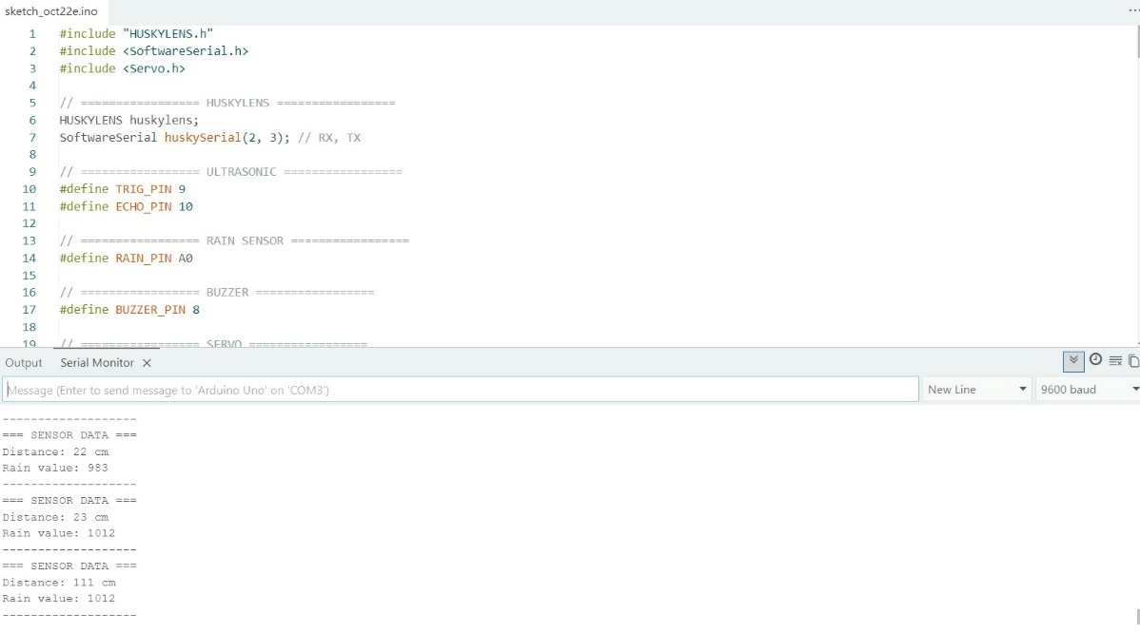
Data obtained from the cane include Rain, Distance
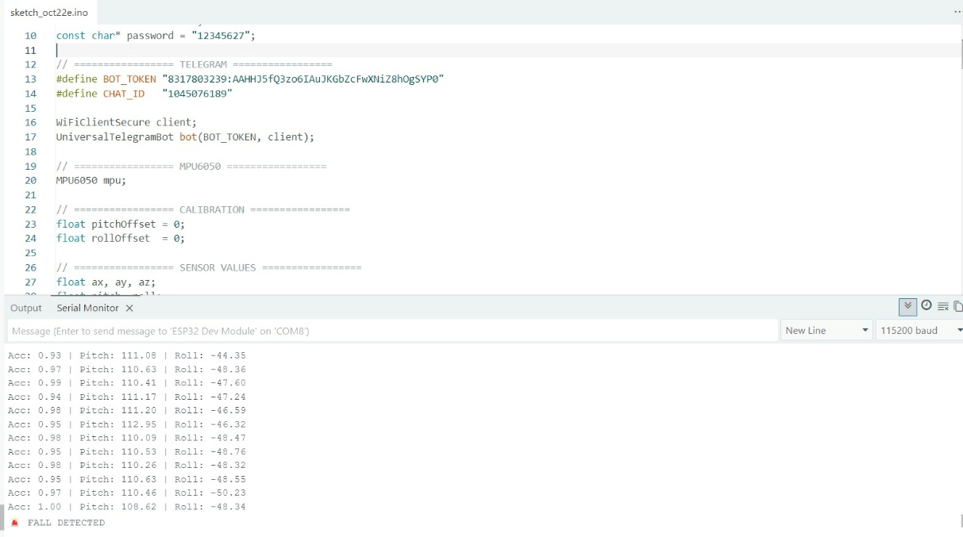
Testing MPU 6040 detection

System Assembly (not fully completed yet)
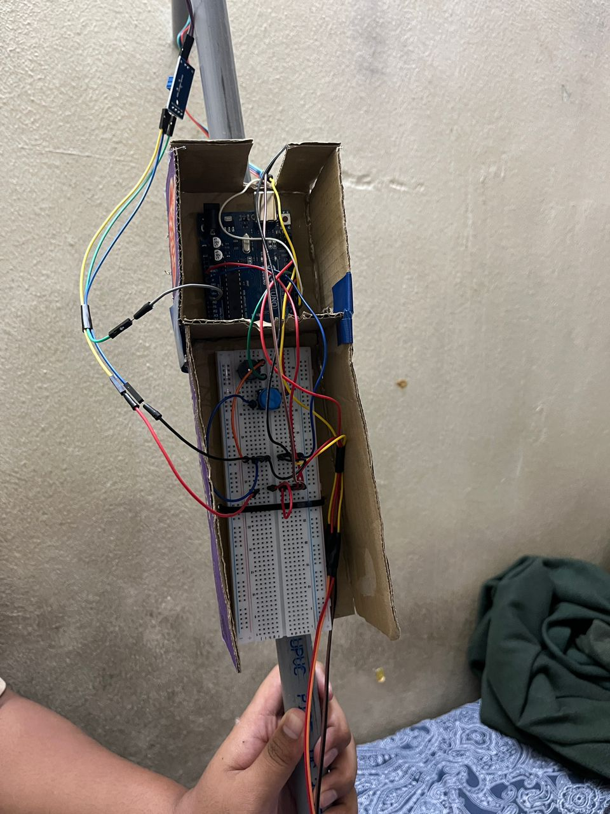
Circuit model that is used for the cane
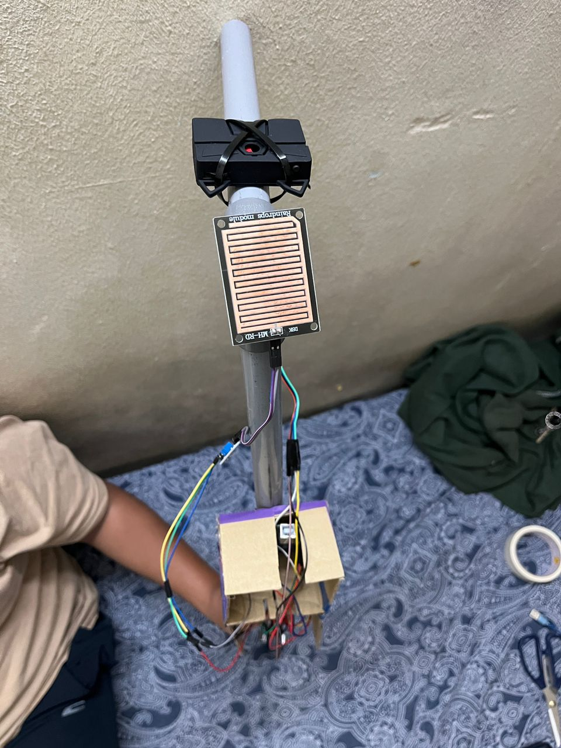
Placement of huskylens and rain detection on the cane

